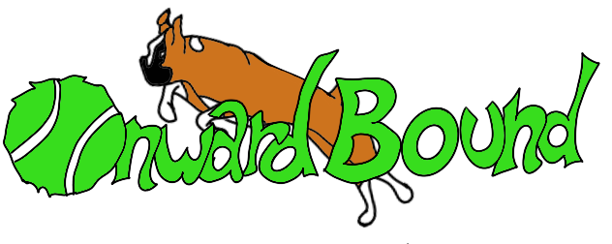

The Puppy Socialization Checklist

based on the Checklist for Socialization by Dr. Sophia Yin

Handling

Checking the ears
Examining mouth, teeth and gums
Brushing Teeth
Squeezing the feet
Handling and trimming the toenails
Pinching or poking the skin
Opening the eyelids
Touching and squeezing the nose
Checking testicles (for males)
Cradling puppy in your arms on its back
Holding him in your lap
Holding puppy upside down
Holding puppy on its back while giving a belly rub
Hugging your puppy
Touching the collar
Grabbing puppy by other part of the body
Wiping body with a towel
Putting on a head halter and harness
Brushing and grooming

People

Women
People of many ethnicities
Tall men
Men with deep voices
Men with beards
Elderly
People wearing hats, helmets
People wearing Ugg® boots
People wearing hoodies
People wearing backpacks
People wearing sunglasses
People with canes, walking sticks or walkers
Teenagers
Children standing as well as playing
Toddlers (walking and squealing)
Infants (crawling)
People running by
Indigent or homeless people
People at night

Animals

Dogs who play well
A dog who will reprimand puppies with appropriate force and restraint for getting into his personal space
Puppies who play well and don‘t get overly aroused
Cats
Horses and livestock (cows, sheep, chickens..)
Any types of pets you may have

Sounds

Thunder
Fireworks
Babies and kids
Alarms & Sirens
Dogs barking
Doorbell ringing
Traffic
Jack hammers, agricultural machinery, loud tools
Vacuum cleaner (especially a Roomba!)

Objects

Skateboards
Rollerblades
Garbage cans outside
Shopping carts
Baby strollers
Wheel chairs
Bikes
Cars
Buses & Trains
Motorcycles
Pots and pans
Blankets or rugs being shaken
Brooms
Balloons
Umbrellas
Bags blowing in the wind
Sidewalk signs
Chairs being dragged
Large plastic garbage bags

Environments & Surfaces
Suburban neighborhood
Residential city streets
High traffic city street
Shopping mall parking lot
Inside buildings
Dog-friendly event (f.ex. an agility or obedience trial)
Location of several different dog training classes
Railway Stations
Woods & Rivers
Elevators
Wobbly surfaces such as a BOSU ball, a board on top of a book, an unbalanced thick tree branch or a wobble board
Wet grass
Mud
Ice, frost, or snow if you will live in such areas
Metal surfaces-such as manhole covers, vet scales
Sand
Concrete
Slippery floors (linoleum, hardwood or marble)

